Record No: 0661
AMY KATHLEEN HARRISON (Kitty)

of Reendesert Lodge, Bantry, Co Cork

2ND dau of Gen Henry Standish Harrison (0662) of Castle Harrison by his wife Amy Georgina, daughter of General de Berry

Birth: 7 Dec 1884
Marriage 1: 24 Jun 1908 at Charleville, Co Cork, Alan Campbell Ferguson
Marriage 2: 27 Jan 1925 at St Andrew’s Church, Westminster William A T B Somerville (0660)
Death: 31 Jan 1962, at Reendesert Lodge, Bantry. Bd 2 February 1962 at The Old Abbey
Cemetery, Bantry

Source: Somerville Index

Further research:

All we know from the Somerville Index is that Kitty’s first husband was Alan Ferguson. Further researches reveal that his middle name was Campbell, that he was the son of Surgeon-Major William Ferguson and that by the time he married in 1908 his father was dead. During the Great War he served in France, arriving there on 1 Oct 1915. The archives from The Times mention his interests in New South Wales, Australia. The probate records show that his estate was worth £33,475 3s 9d when he died, which is worth over £1,040,000 today.

We also know that he converted Reendesert Lodge from two cottages. It was situated on about 60 acres beside the sea in Bantry Bay; there was a small harbour. Alan Ferguson kept an ocean going yacht. His Australian interests prospered substantially and were enjoyed by Kitty long after his death. Regi maintained that he married Kitty in middle age, after she and Bunt had met, under pressure from her father. The inference was that he supported his father in law financially.

After Kitty’s death, Reendesert, and contents (including Somerville property), passed to Roberta Power, the daughter of Kit Power, daughter of Marjorie Barclay, Kitty’s sister. Roberta sold off much of the land, attempted to run the house as a guest house, but then married a Canadian, surnamed Lank, and moved to Canada. The property now belongs to friends of WBRBS and Manon. Bunt’s record GUR head still hangs in the hall.

Kitty had quite a personality, a foil to Bunt’s retiring nature. She was smart, both in appearance and wit.

WBRBS from personal knowledge and conversation with Regi

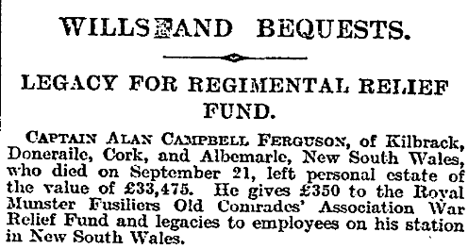
The Times 30 Nov 1920

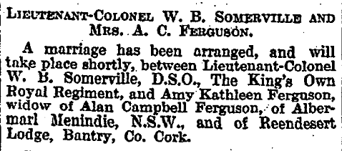
The Times 30 Dec 1924

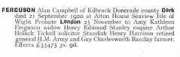

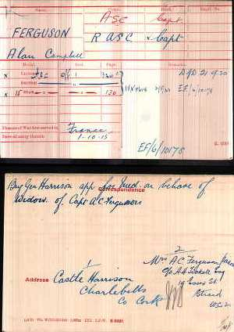

HENRY HARRISON, of Castle Harrison, J.P., m. 1 June, 1849, Marianne, dau. of Robert Stein, of Kilbegie, N.B., and by her (who d. 1882) had issue:

I. STANDISH HENRY, now of Castle Harrison, J.P., late Lt.-Col. Commanding The King's (Liverpool) Regt.; afterwards Col. Com. 101st Regt. District R. M. Fus. atTralee; and Brigadier-Gen. Commanding South Irish Grouped Regimental District;
educated at Trin. Coll., Dublin; b. 27 Feb., 1853; m. 14 July, 1880, Amy Georgina, fourth dau. of Major-General G. F. de Berry, and has issue:

1. Standish, b. 2 Jan., 1882; d. 29 April, 1882.
2. John de Courcy, b. 2 June, 1886.
1. Aline Maude, m. at Charleville, 1 Nov., 1906, Capt. Thomas Julian Goodlake, 4th Battn. Royal Munster Fusiliers, of Ballygarry, Tralee.
2. Amy Kathleen, m. 24 June, 1908, at Charleville, Alan C, son of late Surgeon-Major Wm. Ferguson, A.M.D., and of Mrs. Ferguson, of Rough Hill, Mallow.
3. Marjorie Isabel.
4. Maureen Standish.
5. Dorothy Patricia.

http://www.corkpastandpresent.ie/places/northcork/grovewhitenotes/caherduggantocastlehyde/gw2_82_88.pdf

FERGUSON, Surgeon-Major William, from half-pay, to be Surgeon-Maj or, vice
Patrick P. MI'Dermott, retired on temporary half-pay.
British Medical Journal 7 Nov 1874

